China Dandong Hua Yu Instrument Co.,Ltd

YXQ-200 Pressure Calibrator

Installation and Operational Manual

China Dandong Hua Yu Instrument Co.,Ltd
Add: No. 234 The River City Street Dandong Liaoning Province China
Url:Http://ww.ddhyyq.com E-mail:ddhyyq@sina.com

China Dandong Hua Yu Instrument Co.,Ltd

Brief Introduction
YXQ-200 Pressure Calibrator consists of a 0~25 pound·inch torque meter and a 20~80 pounds manometer(tube shaped), the former one is used to measure the torque value, while the latter one is for measuring the pressure(with pound as the unit of the acting force).By jointly applying these two meters with WLP-208 or WLP-205 average particle size testing device, same compacting level can reappear in measuring process of the particle size, as a result, the measuring accuracy and repetition is highly improved.
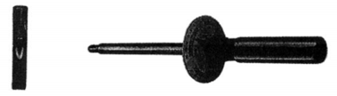
Main Technical indices
1.Torque within the range of:0~25 pound·inch(1 pound·inch/grid)
2.Measuring rang of the pressure:20~80 pounds(pound·inch/grid)
Installation and operation
Before measuring, one should firstly demount the material pressing knob on WLP-208 or WLP-205 average particle size testing device, this done, draw out the three M3 screws from the assembly of cog shaft and wheel, take off the tiny cog wheel axis, demount the saddle-backed washer and fit the axis for the cog wheel back at the assembly in place; and with the lid well installed, screw tightly the three M3 screws again, then use a screw to compress solidly the hex connector beside the torque meter onto the protruding end of the tiny cog wheel axis, plug the torque meter aligningly right into the hex(of the connector). After that, put the manometer on the pedestal 9 within the device, rotate the torque meter anticlockwise so that the cog shaft 5 descend and enter into the manometer, then further rotate the torque meter, the manometer floater starts to descend, and right on the floater, a black line in alignment with the manometer scale would read the pressure value. Therefore, every rotation of the torque meter by one grid(i.e.l pound·inch torque), there will be one pressure value(a force of one pound)to match accordingly.
Note: when the pressure is at 50 pounds (22.7kg),the indicated value of the torque meter in the device is 15 pound inch.
Unit on the scale of the torque meter: pound·inch
Unit on the scale of themanometer: pound
Notes:
1,When using the torque meter, the torsional force shouldn’t be too big, when exceeding 25
pound·inch, it will cause damage to the torque meter.
China Dandong Hua Yu Instrument Co.,Ltd
Add: No. 234 The River City Street Dandong Liaoning Province China
Url:Http://ww.ddhyyq.com E-mail:ddhyyq@sina.com
China Dandong Hua Yu Instrument Co.,Ltd
2.When not in use, the torque meter should be put back in the box to prevent it from dropping on the ground and breaking.
3.Operation should be conducted strictly according to the steps stipulated on this manual, it is banned to hold the scale panel with one hand at the same time holds the handle with another to make it oppositely roate, or the scale panel would not be in alignment with the pointer .If not in alignment, one should draw loose the M4 screw on the scale panel and then slightly rotate the scale panel to make the pointer in alignment with its corresponding location, after this done, screw tightly the screw again.
4.Max.pressure for the manometer should not exceed 80 pounds, or the manometer would be damaged.
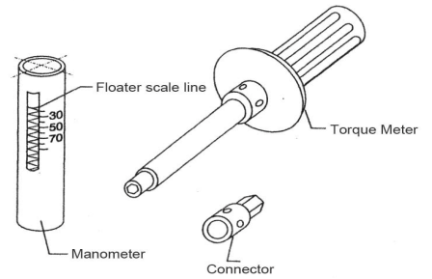
Accessory list
This calibrator consists of following items of accessories:
No. | Product | Qty. | Serial no.
1 | Torque screw opener | 1 | Y-01
2 | Connector | 1 | Y-02
3 | Manometer | 1 | Y-03
4 | Manual | 1 | Y-04
5 | Quality Certificate | 1 | Y-05
All above items of accessories would be packed in one box, customers can open the box upon shipment arrival and check if all is on lists, if not just reach us in no time, should it be any damage during transportation, keep it untouched and assert claim on the forwarder accordingly.

China Dandong Hua Yu Instrument Co.,Ltd
Add: No. 234 The River City Street Dandong Liaoning Province China
Url:Http://ww.ddhyyq.com E-mail:ddhyyq@sina.com

