China Dandong Hua Yu Instrument Co.,Ltd
Patent number：ZL 2016 2 1458734.5

WLP——216
Average Particle Size Testing Device
The specification for installation and usage

China Dandong Hua Yu Instrument Co.,Ltd

China Dandong Hua Yu Instrument Co.,Ltd
Add:No.234The River City Street Dandong Liaoning Province China
Url:Http://www.ddhyyq.com E-mail:ddhyyq@sina.com

- 打开主机与笔记本电源，运行20分钟。检查笔记本USB口是否与主机连接上。
Turn on the power supply for the machine and the laptop,and then run for 20 minutes.
Check the USB to see whether it has connected with the machine.
- 双击粒度仪的测试系统图标，进入欢迎页面，双击此界面后，运行测试系统。
Double click the icon for this system and enter the welcome interface.After double click this interface,the testing system will run.


三、进入到测试系统后，要先选择串口（我的电脑—设备管理器—通用串行总线控制器中查找COM），完成此步骤后，若左上角显示“串口已打开”则可点击“OK”进入下一步，此时，可进行测试。
After enter the testing system,please select the serial interface(my computer-device manager-check COM from the controller of universal serial bus(USB).Next,please click “OK” after the words “the serial interface has been opened” display on the top left corner.Then you can start the test.

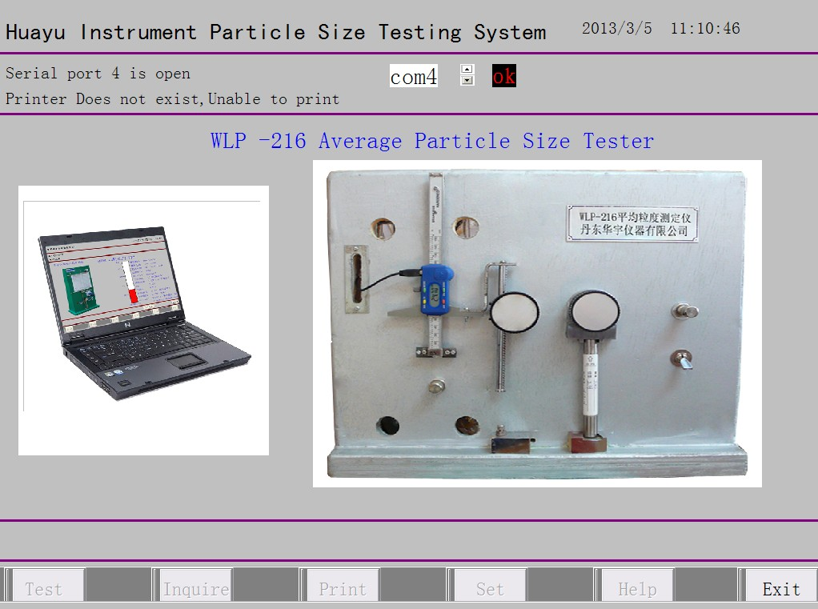

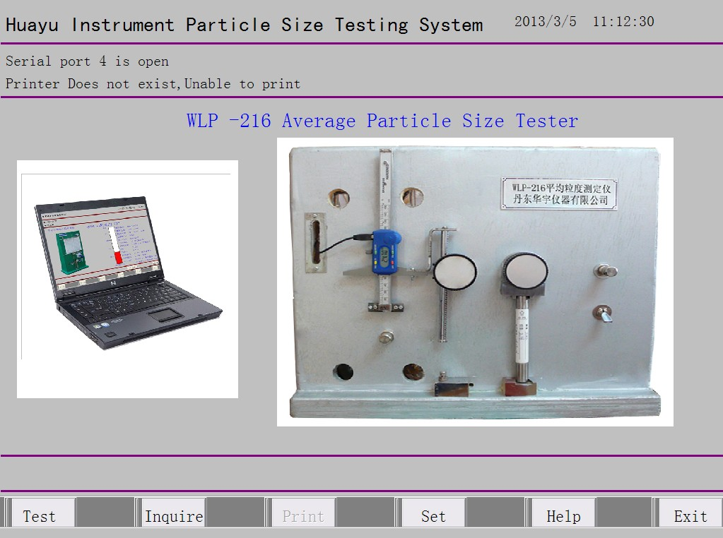

- 点击左下方“测试”按键，进入“粒度原始信息测定”界面，单击鼠标左键选择需要修改的信息，必须按回车键才能完成修改，否则无效。如果测量0.2-20微米，标准值设定为标准管的高值。（例如，标准管高值为5.90，则标准值设定为5.90）点击“下一步”按键进入下一界面。
Click the “test”button to enter into the interface of “set up the original information for the particle size”.Click the left mouse button to select the information which is necessary to revise,but please remember to press the “enter ”button to finish it,or else it won’t be in effect.If you want to measure 0.2-20 micron,please set up the high value of standard tube as the standard value.(e.g. the high value of standard tube is 5.90,then 5.9 will be set up as the standard value).Click “Next” button to enter into the further interface.

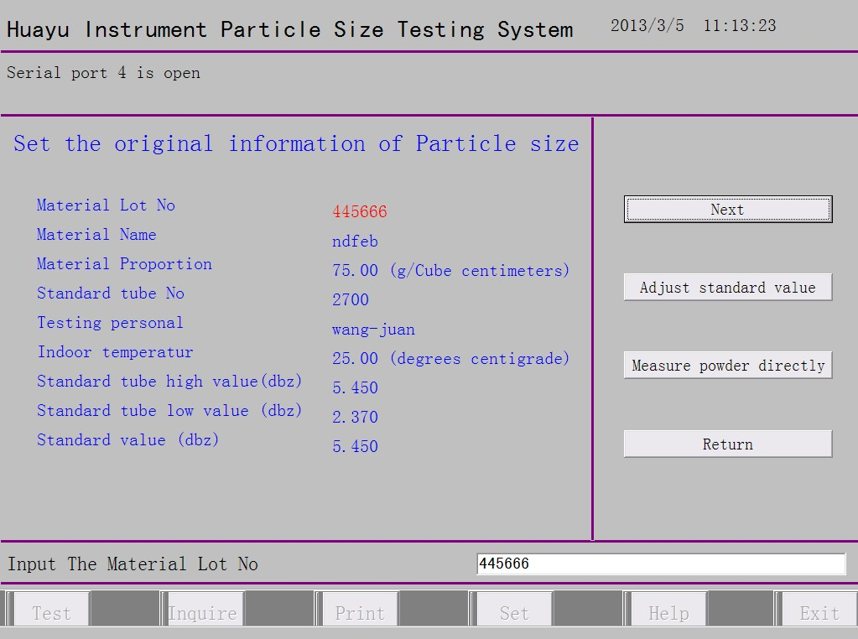

- 在主机上安装空试样管，压实后，电脑界面显示红色水柱上升，这时，仪器显示的工作压力应为50±0.2厘米水柱，只有达到此范围，才可进行下一步。若达不到此值，应向稳压器内注水，若已超过此值应从稳压器内抽出一些水，直到合适为止。
Install the empty sample tube on the measuring pedestal and press it tightly,the computer screen will display the red water column rises.At this time,the equipment should display that the working pressure is 50±0.2cm .It can’t be proceeded the next step until the working press reach this range.If it can’t reach this range,please fill some water into the manostat,whereas,please pump some water from the manostat until getting fitted.
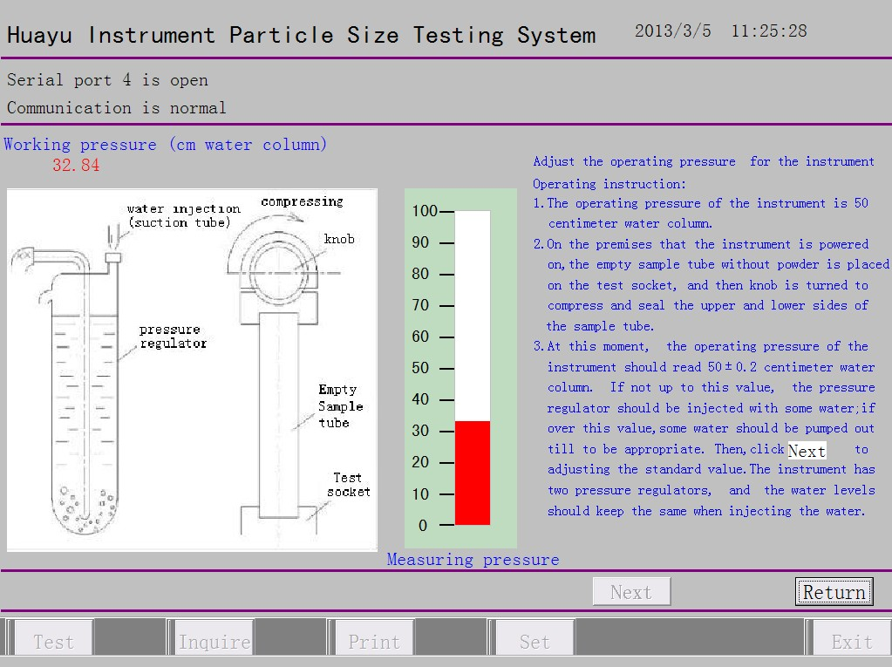

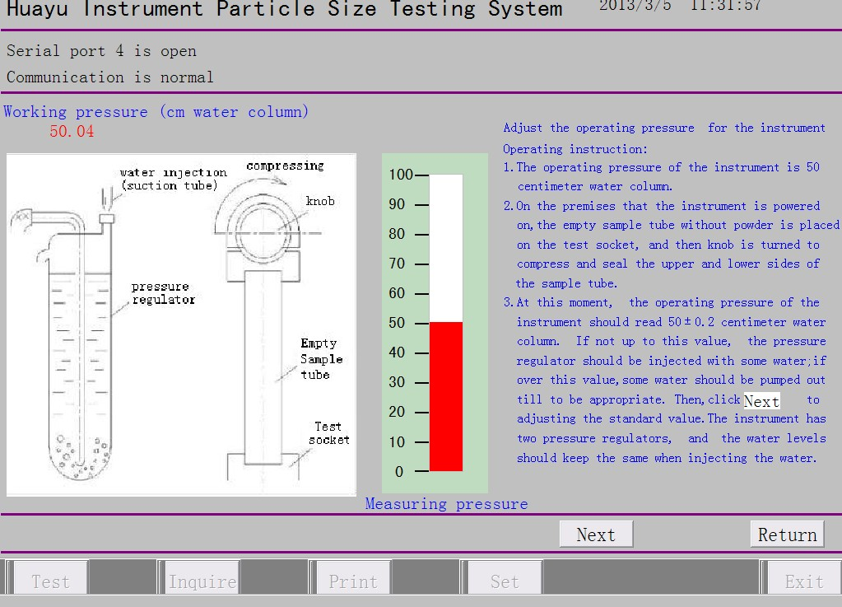

- 卸下试样管，换上标准管，压紧。此时标准值水柱开始上升，一分钟后稳定，稳定后如水柱高于标准值则进行不了下一步，需调节空气压力调节阀，顺时针旋转为上升，逆时针旋转为下降，（由于空气调节阀为微调阀，调节时需慢慢细调）直到达到标准值，可点击“下一步”。
Remove the sample tube and change the standard tube instead,then press it tightly.
At this time,the water column is rising until it keeps steady in one minute.You can’t proceed the next step if the water level is higher than the standard value,please adjust the air pressure valve until it reach the standard value,when clockwise rotate the knob,the water level will rise,whereas counterclockwise rotate the knob,the water level will descend.,(Please adjust the knob slightly and slowly owing to its special characteristics).Then you can click “Next” button.
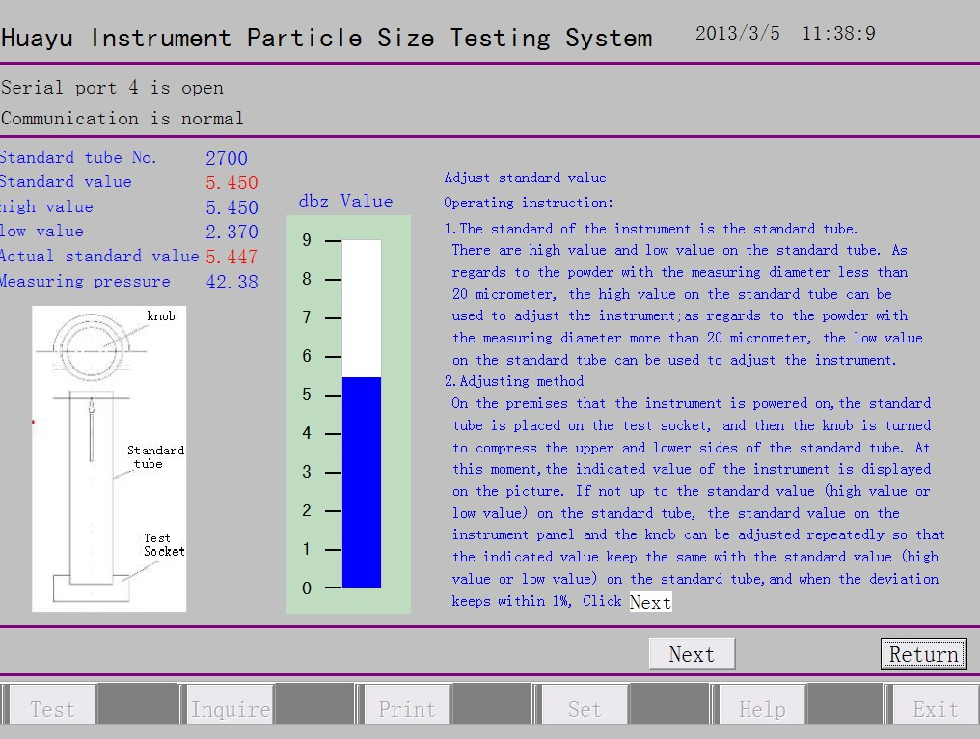

- 进入“压实粉料”界面，此时打开数显试样高度尺，用两只多孔铜塞和两片滤纸放入底座压实，高度尺要归零。此时仪器已经校对好，并可以开始测试样品。把装好样品的试样管安装到压料底座，旋转压料旋钮压紧，压紧后，点击“确定高度”。
Enter into the interface of “pressed powder material ”，and open the digital ruler for the sample test,put polyporous copper plug and two pieces of filter paper into the pedestal and press them tightly,adjust the digital ruler to the zero point.At the time,this equipment has calibrated well and it can start to measure the sample.Put the sample tube filled with powder on the pressing material pedestal,rotate the pressing material knob and press it tightly.After that,please click button“fix the height”.
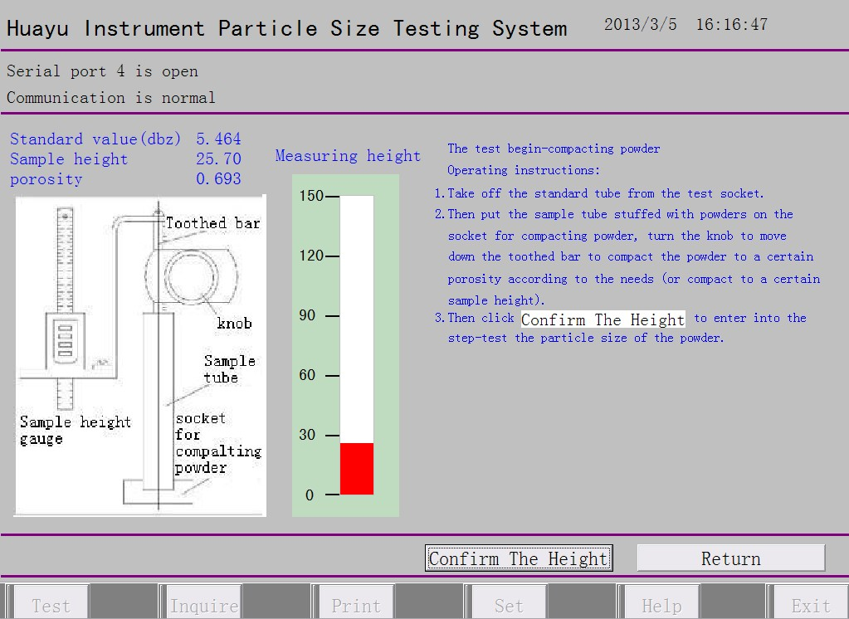
- 把压好的试样管轻拿下来，放到测试底座上压紧。此时会在“测定粉料粒度”界面显示比表面积、测量压力、平均粒度、孔隙度等信息。可点击“保存”按键进行保存。
Remove the sample tube carefully and put it on the testing pedestal ,then press it tightly.At this time,The ratio surface,pressure,average particle size,gap size,etc will be shown on the interface of “measuring the particle size of powder”.Please click the “Save” botton to keep them.
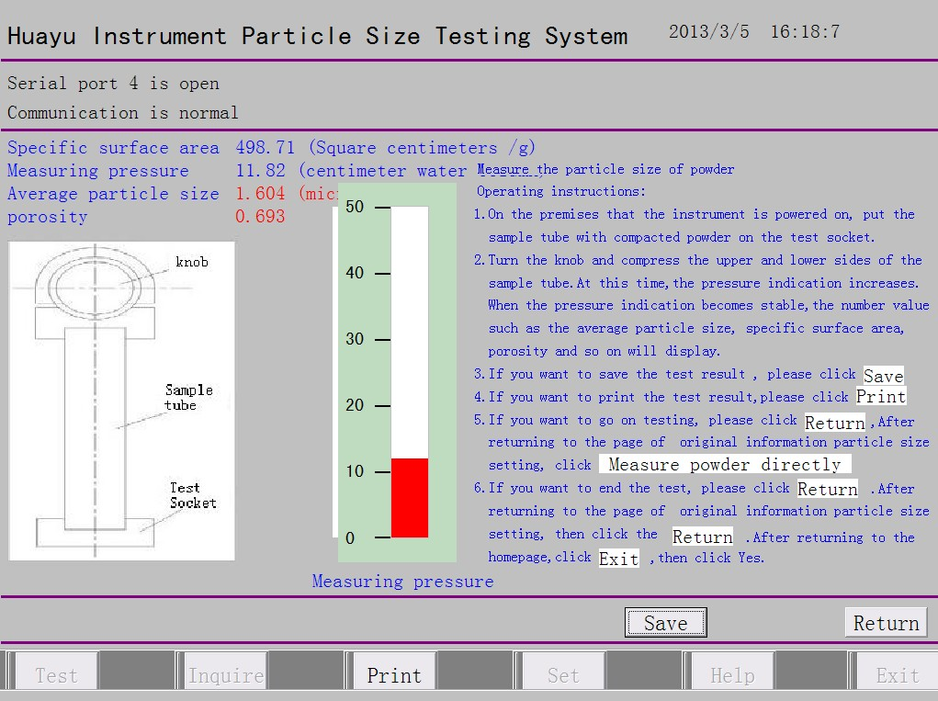
- Dosage and loading of powder
- The dosage shall be equal to the true specific gravity of the material. For example, the true specific gravity of ferrite material is 5g/cm³, the dosage of powder shall be 5g then;
- Instrument for weighing: 1%-1% balance;
- The powder shall be dry; dry the powder if any moisture;
- Load the powder: see the illustrations below
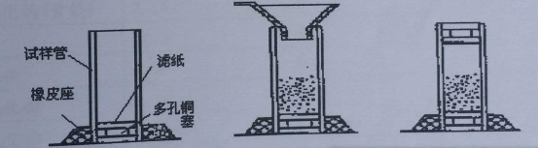
Sample tube
Rubber seat
Filter paper
Porous cupper plug
- Insert a piece of filter paper and a porous cupper plug into one end of the sample tube.
- Insert the sample tube into the rubber seat as shown in the picture.
- Feed the powder (weighed with a funnel) into the sample tube and later put a piece of filter paper and a porous cupper plug onto the top end of the sample tube. Then the sample tube can be used for pressing and particle size testing.
- Common faults and solutions
  - Communication error:
    - Poor contact of USB cable or the USB cable is broken and is thus false connected to the computer;
    - Software of the USB cable is unloaded; re-install the software (namely, drive program of the USB cable);
    - Improper serial port. If two serial ports are already open, only one correct port can be selected (namely, the USB interface). Method: Right single click My Computer with the mouse --- Left double click the Device Manager with the mouse ---- Left double click the Port and Prolific USB-to-Serial Comm Port (comx) appears. Note: X is reference No. of the open serial port. For example, when x is 5, select 5 on the menu.
    - The host is not started yet.
    - Power failure in the way. Re-start the computer now.
    - Shutdown of either the computer or the host can result in communication error. If so, it is necessary to re-start the computer or the host.
  - Height gauge fault:
    - The red light of the height gauge connected with circuit board of the single board computer is off, so are the red light of the 9-line plug on the height gauge.
    - When the battery (1.5V) on the height gauge is lower than 1.35V, the height gauge may have no signal output. At this time, both the red light on the circuit board and the red light on the 9-line plug on the height gauge are off.
    - The height gauge shows no changes in reads----the height gauge is shut down. Take out the battery and wait for 1 minute. Then, re-install the battery and the height gauge can be used again.
- True density of common materials (for reference only)
Powder | True Density, g/cm³ |  | Powder |  | True Density, g/cm³
Tungsten | 19.3 |  | Cobalt oxide |  | 5.70-6.70
Tungsten carbide | 15.7 |  | Aluminum oxide |  | 3.90-4.00
Tungsten dioxide | 11.0 |  | molybdic acid |  | 3.124
Tungsten trioxide (yellow tungsten) | 7.16 |  | Tantalum |  | 16.69
Molybdenum | 10.2 |  | Manganese |  | 7.20
Molybdenum carbide | 9.18 |  | Tungstic acid |  | 5.50
Molybdenum dioxide | 6.34 |  | Iron |  | 7.86
Molybdenum trioxide | 4.52 |  | Cobaltic oxide |  | 5.18
Blue tungsten | 7.30 |  | Iron oxide red |  | 5.00-5.25
Antimony trioxide | 5.20 |  | Ferrous oxide |  | 5.70
APT (ammonium molybdate) | 4.50 |  | Magnesium oxide |  | 3.58
Neodymium oxide | 7.24 |  | Boric oxide |  | 1.85
Calcium oxide | 3.35 |  | Zinc oxide |  | 5.606
Barium oxide |  | 5.72 |  | Iron oxide |  | 5.12-5.24
Powder |  | True Density, g/cm³ |  | Powder |  | True Density, g/cm³
ammonium molybdate |  | 2.38-2.95 |  | Strontium |  | 2.60
Cobalt |  | 8.90 |  | Samarium cobalt |  | 8.50
Barium |  | 3.76 |  | Nb |  | 8.60
Magnesium |  | 1.74 |  | Strontium carbonate |  | 3.70
Tantalum |  | 16.6 |  | Carbon trioxide |  | 8.74

Attachment: List of accessories of the average particle size tester WLP-2016
S/N | Accessory | UOM | Quantity
1 | Dell computer | set | 1 can be customized)
2 | Standard tube | pcs | 1
3 | Sample tube | pcs | 1
4 | Porous cupper plug | pcs | 2
5 | Rubber seat | pcs | 1
6 | Filter paper (diameter: 20) | pcs | 500
7 | Push rod | pcs | 1
8 | Funnel | pcs | 1
9 | Fuse (1A) | pcs | 1
10 | Indicator light (6v/1.5A) | pcs | 1
11 | Drying agent | g | 50
12 | Brush | pcs | 1
13 | USB cable (1.5m) | pcs | 1
14 | Software (U flash disk) | pcs | 1
15 | Button cell | pcs | 2
Dandong Huayu Instrument Co., Ltd
Address: 234 Jiangcheng Street, Dandong | Bank: Bank of Dandong the Development Area Branch
Postal code: 118000 | Account No.: 0908 0101 2010 1000 9807
Tel: 0086-415-2825726, 2825727 | Mobile phone: 008-133 0495 3619
Fax: 0086-415-2837667 | Website: www.ddhyyq.com
E-mail: ddhyyq@sina.com

